UNIVERSITY OF ENERGY AND NATURAL RESOURCES, SUNYANI
DEPARTMENT OF INFORMATION TECHNOLOGY AND DECISION SCIENCE
SCHOOL OF SCIENCE


PROJECT REPORT
TOPIC
ONLINE FOOD DELIVERY APP FOR UENR STUDENTS
SUBMITTED BY
MAXWELL MENSAH (UED2700822)
DA-ROCHA FRIMPONG CHRIS (UED2701422)
SAMUEL FRIMPONG MENSAH (UED2707722)

Submitted in partial fulfillment of the requirement for the award of a Diploma in Information Technology

DECLARATION

We, MAXWELL MENSAH (UED2700822), DA-ROCHA FRIMPONG CHRIS (UED2701422), SAMUEL FRIMPONG MENSAH (UED2707722), at this moment declare that the study was carried out and written by us and that all sources of information have been acknowledged and that we are wholly responsible for any acts that may infringe on the research ethics policies of the University.

MAXWELL MENSAH ………………… … 01/10/24…………
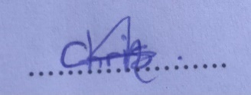
(UED2700822) SIGNATURE DATE
DA-ROCHA FRIMPONG CHRIS ………………… ……01/10/24……………

(UED2701422) SIGNATURE DATE
SAMUEL FRIMPONG MENSAH ………………… ……01/10/24……………
(UED2707722) SIGNATURE DATE


MR. MICHAEL OPOKU ……………… …02/10/24………………
(SUPERVISOR) SIGNATURE DATE

PROF. DR. PETER APPIAHENE ………………… …02/10/24……...
(HEAD OF DEPARTMENT) SIGNATURE DATE

DEDICATION

We dedicate this project to GOD, our creator, our source of inspiration, wisdom, knowledge, and understanding. He has been the source of our strength throughout this program and on His wings only we have soared. We also dedicate all our efforts and hustle of the educational life to our parents and colleagues who are making our educational dream successful.

ACKNOWLEDGEMENT

This project's creation has been both difficult and exciting. This project involved multiple experiences and inquiries through observing taking into consideration and providing insights that resulted in this product. We thank God for keeping us safe and well during work hours. We thank the University of Energy and Natural Resources and the Department of Information Technology and Decision Science for the outstanding chance they provided. We value the kindness and compassion our parents and family members gave us while working on this project. We also thank our supervisor for his support. We received valuable help from MR.MICHAEL OPOKU, including guidance and assistance to complete our tasks. We acknowledge the support from our peers at different universities and express gratitude for their good deeds directed our way. May you all receive the grace of God.

ABSTRACT

This project describes the development of a Food Delivery App platform connecting local artisanal food vendors with customers. However, the student faces significant obstacles such as the inconvenience of waiting for lectures to close before heading to restaurants or fast food places to join queues is very frustrating for most UENR students. The app will enable students to discover, order, and enjoy unique, handmade food products from local food. The proposed system will facilitate easy registration, ordering, and tracking of their food with a user-friendly interface, secure payment processing, and real-time order tracking. Additionally, the platform will include an educational module to raise public awareness about food.This app aims to revolutionize the food delivery experience in Sunyani.
The project is to change the food delivery experience in Sunyani by using modern technology to create a platform that creates accessibility for all. Through this app, students and teaching and non-teaching staff will have the chance to explore a diverse range of local food to support small brick-and-mortar fast food joints. All with the hassle-free delivery experience. This will also contribute to the growth of local food vendors in the entire community.

Table of Contents
DECLARATION 2
DEDICATION 3
ACKNOWLEDGEMENT 4
ABSTRACT 5
CHAPTER ONE 12
INTRODUCTION 12
1.1 BACKGROUND 12
1.2 PROBLEM STATEMENT 14
1.3 MAIN OBJECTIVES 15
1.4 SPECIFIC OBJECTIVES 15
RESEARCH QUESTIONS 16
1.6 SIGNIFICANCE OF THE STUDY 16
1.7 SCOPE AND LIMITATION 16
CHAPTER TWO 18
LITERATURE REVIEW 18
2.1 INTRODUCTION 18
2.2 RELATED WORKS 18
CHAPTER THREE 20
METHODOLOGY 20
3.1 INTRODUCTION 20
3.2 DATA COLLECTION METHOD 20
3.3 DATA COLLECTION INSTRUMENT 20
3.3.1 Our Observation from Our Analysis 20
3.4 SAMPLING TECHNIQUE 28
3.5 SYSTEM DESIGN 30
3.5.1 TECHNOLOGY STACK 31
3.5.2 Description of The Proposed System 31
A Brief Description of How the System Will Operate: 31
3.5.3 Feasibility Analysis 32
3.6 REQUIREMENT ELICITATION 32
3.6.1 Requirement Analysis 32
3.6.2 Functional Requirements 32
3.6.3 Non-Functional Requirements 33
3.6.4 User Performance/Usability 33
3.7 THROW AWAY PROTOTYPE MODEL 33
3.8 FLOWCHARTS OF THE PROPOSED SYSTEM 34
3.9 ARCHITECTURAL DESIGN 36
3.9.1 Physical Requirement 36
3.10 Use Case Diagram 37
CHAPTER FOUR 38
RESULT AND DISCUSSION 38
4.1 INTRODUCTION 38
4.2 SYSTEM DESIGN AND IMPLEMENTATION 38
4.3 USER INTERFACES 39
4.3.1 Sign In page 39
4.3.2 Sing Up page 41
4.3.3 App Menu Bar 43
4.3.4 Food menu screen 44
4.3.5 Location 44
4.3.6 Cart Page 45
4.3.7 Payment Page 46
4.3.8 Display Receipt 48
CHAPTER FIVE 49
SUMMARY, RECOMMENDATION AND CONCLUSION 49
5.1 INTRODUCTION 49
5.2 RECOMMENDATION 49
5.3 FUTURE WORKS 49
5.4 CONCLUSION 50
REFERENCE 51
APPENDIX 53

LIST OF FIGURES
Figure 3.1Overall experience with the food delivery app 20
Figure 3.2 overall experience on why they place orders through the delivery app 20
Figure 3.3 Overall estimated delivery time and arrival time accuracy 21
Figure 3.4 Overall experience with the food taste 22
Figure 3.5 Overall satisfaction with the food menu 22
Figure 3.6 overall experience when navigating through the app 23
Figure 3.7 Experience with any issues 24
Figure 3.8 Overall experience with the food delivery app 24
Figure 3.9 recommendation of the app 25
Figure 3.10 payments transparency options 26
Figure 3.11 how likely would they continue to use the food delivery app 26
Figure 3.12 The Throwaway prototype model 32
Figure 3.13 Flowchart of the proposed system (Adopted from Demo 2022) 34
Figure 3.15 Architectural Design 35
Figure 3.16 Use case diagram of the system 36
Figure 3.17 Database diagram 37
Figure 4.1 Sign In page 40
Figure 4.2 Sign Up page 42
Figure 4.3 App Menu Bar 43
Figure 4.4 Food Menu Page 44
Figure 4.5 location page 45
Figure 4.6 Cart page 46
Figure 4.7 Payment page 47
Figure 4.8 Receipt Page 48

LIST OF ABBREVIATIONS
OFD……………………………………………. Online food delivery
HCI……………………………………………. Human-computer interaction
CAGR…………………………………………. Compound Annual Growth Rate
UI………………………………………………User Interface
UX……………………………………………...User Experience
SDLC…………………………………………...Software Development Life Cycle
UENR………………………………………University of Energy and Natural Resource

CHAPTER ONE

INTRODUCTION

1.1 BACKGROUND
Food is said to be one among the need of life. The National Geographic Society (2024) described food as the substances and nutrients needed to construct body tissues, fix broken or worn out tissues, and regulate processes occurring in the body. Energy sources are the food ingredients which make our body function. The operations of a restaurant may involve preparing foodstuffs, preparing cooking, serving food and beverages to the clients. So, most of the food is eaten in the place they are ordered but many restaurants will have provisions for to go as well as delivery services. Food is substances necessary for constructing, heal, and maintain body structures and controlling of essential functions. Nutrients are substances which supply energy in the human body. This business involves preparing and selling of food and beverages to the customers by a restaurant. Food consumed in restaurants is mainly in the restaurants but mostly came into customer’s place, though some restaurants do take-outs and delivery. The food delivery applications of the global have generated revenue of about 95.4 billion US dollars in the year 2018, and major amount of the revenues originating from China with approximately 38.4 US dollars of the revenues in the year 2018 (Statista Reports, 2018). Global market will be growing at a CAGR of around 9.6% for the year 2018 to 2023, and has statistically reached nearly US $ 137.6 billion as given in the Statista Reports, 2018.
The students at University of Energy and Natural Resource Sunyani- Ghana need food and transport since most reside in the campus. According to this study students often purchased food away from the university because they found the cafeteria's dishes unappealing. The most common occurrence happens when the menu is repeated or the meals provided to clients by the cafeteria. Who live inside the campus. Students chose to buy food away from campus because they were dissatisfied with food in the university eatery. The biggest factor is the regularity of the dishes provided by the food service. Without their own cars most students had no means to get food from sources beyond the university. Students on transport must realize that fuel prices are usually more expensive when they prefer to dine at a food court or a restaurant away from the university. The objective of this research is to explore the demand in the market and the vital functions of the food delivery application as viewed by students. In society people increasingly rely on digital tools to order and pay for food.
The objective of this research is to analyze the consumer experience related to service delivery within the digital food service market. In 2020 Klein et al. examined cross-media impacts and consumer buying habits to illuminate managing the customer journey driven by social media use in the online space. Klein et al. (2020) propose that there is a need for additional analysis of how customers rate the experience provided by online services. The ongoing research into developing challenges drives this study to examine the online consumer experience in service settings with an emphasis on the food delivery industry and assess customer expectations in this field. As the Internet played a vital role in society individuals adapted techniques in various domains of their lives. In this context the Internet serves as an important element while smartphones greatly influence how people use it in their daily lives (Zhitomirsky Geffet & Blau 2016). A worldwide trend towards the rise of digital food delivery applications has welcomed many renowned brands including Uber Eats and GrubHub and numerous firms that supply fast food and restaurant service while tracking orders live and allowing customers to order and pay directly through applications resulting in enhanced restaurant revenues and customer bases.

1.2 PROBLEM STATEMENT
While convenient food delivery apps have become a trend nowadays a significant number of customers living in big cities remain unsatisfied with high fees and long delivery time, a relatively limited choice of restaurants, and low satisfaction and loyalty to service, thus leaving room for improvement of the whole food delivery process. As Collison (2020) noted the online food delivery services has disrupted the traditional restaurant business model mostly associated with offline services.
The offline type of restaurant business is significantly affected by the growing popularity of online food delivery services. Such change has raised the demand for research findings on the impact of such services more so the impact on sales in physical stores. The study therefore aims at developing an environment that simplifies the process of online food delivery to UENR students via a mobile application in Sunyani. This research focuses on the OFD sector with a focus on food delivery to customers so as to understand last mile food delivery toward the achievement of a fossil free sustainable city. It was expected that quantitative studies with customers of the food delivery services at University of Energy and Natural Resources would afford somewhat detailed information on how the food is delivered to the consumers. We have also considered the implications available to OFD companies to mitigate emissions from last-kilometer deliveries in several hostels. Knowledge of the last-kilometer delivery services, general, and specifically the last-kilometer online food delivery is crucial knowledge for the UENR to be able to implement policies that meet the demand of its students without necessarily crossing the campus perimeter.

MAIN OBJECTIVES
- Increase Restaurant Options: Partner with lots of establishments to present unique types of food for patrons.
- User-Friendly Interface: Build a basic interface that raises the experience level for all individuals.
- Accurate Delivery Estimates: Create a trustworthy approach for quickly estimating and executing orders.
- Customization Options: Let customers create their orders aligned with what they love and enjoy.
- Seamless Payment procedure: Encourage a safe and efficient payment approach for users to facilitate simple transactions.

SPECIFIC OBJECTIVES
The mission is to grow the user count using original marketing methods that simplify the experience for users. Establishing partnerships will expand when fair commission structures are in place for restaurants. Improve delivery speed while increasing cooking times in restaurants and broadening the area served by the delivery service. Feedback systems will elevate the satisfaction rates of users. Offer charming deals and secure happy users stick with the app. Cutting delivery times increases restaurant productivity and expands delivery services while establishing a rating system that uplifts customer satisfaction. Boosting restaurant partnerships can occur from offering strong commission rates. Speed up delivery times and speed up restaurant cooking to broaden the reach of the delivery service. Measuring customer opinions will raise overall levels of satisfaction. Deliver customized promotions while making sure pleased customers stick around on the app. Join forces with restaurants by sharing advantageous commission types. Shorten delivery times at bistros and speed up restaurant food preparation methods while broadening the distribution area. Raise engagement by developing a trustworthy system for reviews and ratings. To keep users engaged while ensuring a successful retention rate faculty should provide value-added incentives.

RESEARCH QUESTIONS
- To what extent are delivery methods of current online food delivery services in line with the University of Energy and Natural Resources action plan to become great in the future?
- What challenges are online food delivery companies facing in lowering delivery charges?

1.6 SIGNIFICANCE OF THE STUDY
The approach that the present paper proposes is to offer insights on the creation of an optimized online food delivery application that would enhance meeting customers’ requirements positively impacting the restaurant partners and business development to create a more satisfying and stable food delivery system. This will enable determination of the impact that the Food delivery market will have towards the realization of the improved revenue, growth and competitiveness of the related solutions.

1.7 SCOPE AND LIMITATION
This research covers the detailed investigation of the customer choices, behavior, and satisfaction in the food delivery market, the strategies for restaurant partnerships, and the concepts for increasing revenues, supply chain optimization, as well as the monetization approaches for the growth of effectiveness, customer-oriented, and sustainable food delivery ecosystem for deciding on the further effective evolution of the market.
As such, According to some of the major limitations of this study include: geographic scope, responding customers’ self-reports, omission of non-technology-based delivery methods, and response bias, which may affect the generalization of the outcomes to various environments and populations and, thus, call for future research to investigate the multi-dimensionality of the food delivery market globally.

CHAPTER TWO

LITERATURE REVIEW

2.1 INTRODUCTION
Over the last few years, the online food delivery market has had significant growth and with this shifting the way people get to order and consume food. Due to new technologies and every evolving customer needs the industry has taken an obvious change towards online ordering and delivery. Consequently, evaluating the strategies of the OFD market has become relevant for restaurants and food delivery services. This literature review shall strive to present existing literature on the OFD policy and categories factors that determine consumers, restaurant integration, delivery and distribution, and the higher food sector.

2.2 RELATED WORKS
This work extends earlier research on low impact mobile applications; however, the purpose of this paper is to establish if applied guidelines and low impact features are wanted on small screens as well. Statista noted here that mobile internet has been more affordable and popular in recent years due to the most accessible and inexpensive mobile devices smartphones, Statista (2023b). A user overall use 192 minutes per day on the internet and the primary device for internet usage is a smartphone. Mobile internet contributes more than 57% to the global website traffic as posted by Statista (2023c) to justify why this study should be conducted on the mobile version.
Android subscribers tapped on, creating 143.2 billion downloads in 2020 and rising to 430.2 billion in 2022 according to Statista (2022). Due to the rise of the mobile devices, many online food delivery applications have been developed and are now considered to be one of the fastest growing mobile commerce industries according to Forbes (2021). Online food delivery refers to an application where users can search as well as select the menu available on the application, and provide their delivery details. Statista (2023d) highlight that convenience is one of the most common motivations to order food online.
This implies that there is more of such low impact mobile screen focused research needed in the food delivery industry and hence this study focuses on the food delivery mobile application designs exclusively. Greenwood (2021) notes that the environmental footprint of the Internet is a vast and a significant subject that has to be addressed from the frontend and the backend. According to the problem statement, the web developers have begun migrating to low impact solutions.
However, these solutions are quite recent and as per Greenwood (2021) are not much recognized by the users. Another critique by Guimaraes (2017) notes that he opined that one of the most significant parts of driving product development is the demands of the consumers. Thus, an empathy-driven rise in user awareness and consumer demand could be the critical mass its designers and web developers worldwide need to start going green. This research seeks to help introduce low-impact design to the targeted users based on the front-end of an interface and back-end of back-end development.

CHAPTER THREE

METHODOLOGY

3.1 INTRODUCTION
Qualitative and quantitative approaches were applied to collect data from multiple participants in this study. The survey's participants included instructors and non-instructor personnel from the University as well as student and food vendors. With this method of inquiry data can come from multiple sources and is ideal for statistical analysis. It supplies a remarkable opportunity for gathering evidence and either affirming or rejecting a hypothesis statistically.

3.2 DATA COLLECTION METHOD
For gaining customers’ perceptions, a set of questionnaires were administrated online and for the physical food sellers, we interviewed them face to face. Further information was gathered via test user observation and app statistics during the application testing.

3.3 DATA COLLECTION INSTRUMENT
In this project the main data collection methods included survey questionnaires and interviews.

3.3.1 Our Observation from Our Analysis
Figure 3.1 indicates that 52.4% of pupils indicates that they were satisfied, 23.8% also indicate that they were very satisfied and 23.8% also indicated that were neutral when they use the app.
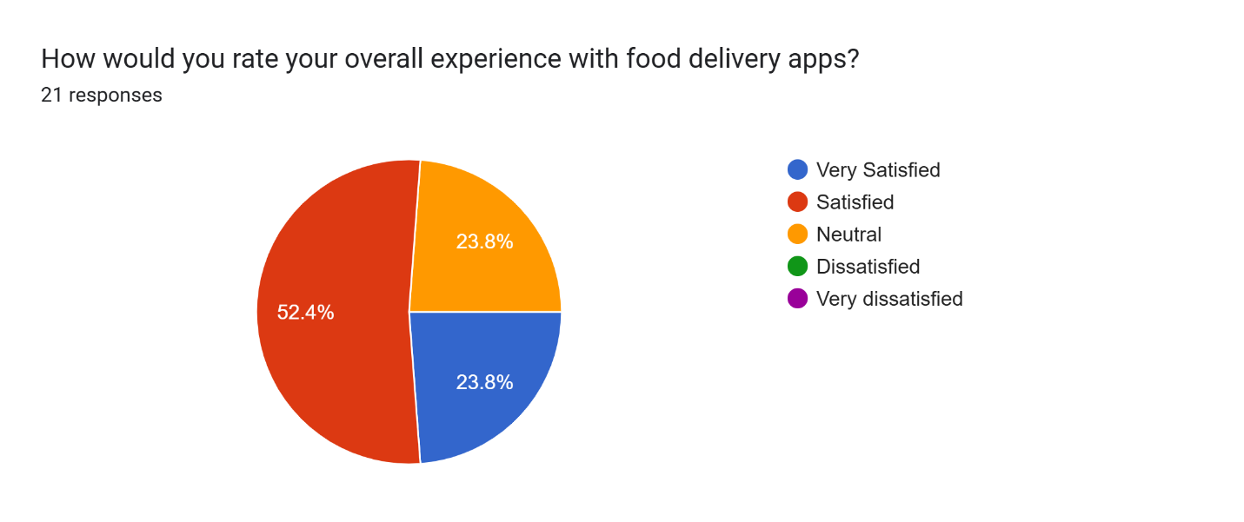
Figure 3.1Overall experience with the food delivery app

Figure3.2 indicates that 66.7% of pupils indicated that it was easy when they placed an order whenever they used a food delivery app, 23.8% indicated that it was very easy when they used the app to place order while 9.5% show that they were neutral when they use the app to place order.
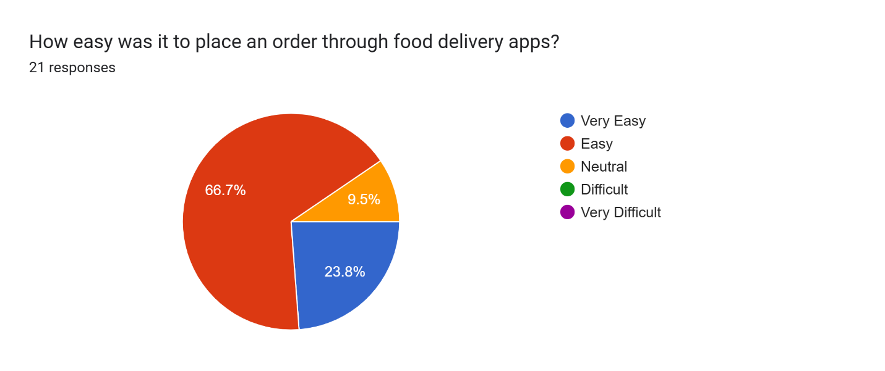
Figure 3.2 overall experience on why they place orders through the delivery app
Figure 3.3 indicates that 42.9% of the pupils who use the app show that the time they received their food was neutral,47.6% of the pupils also indicated that it was easy.4.75% of the people indicated that it was difficult and 4.75% also indicated that it was very easy.

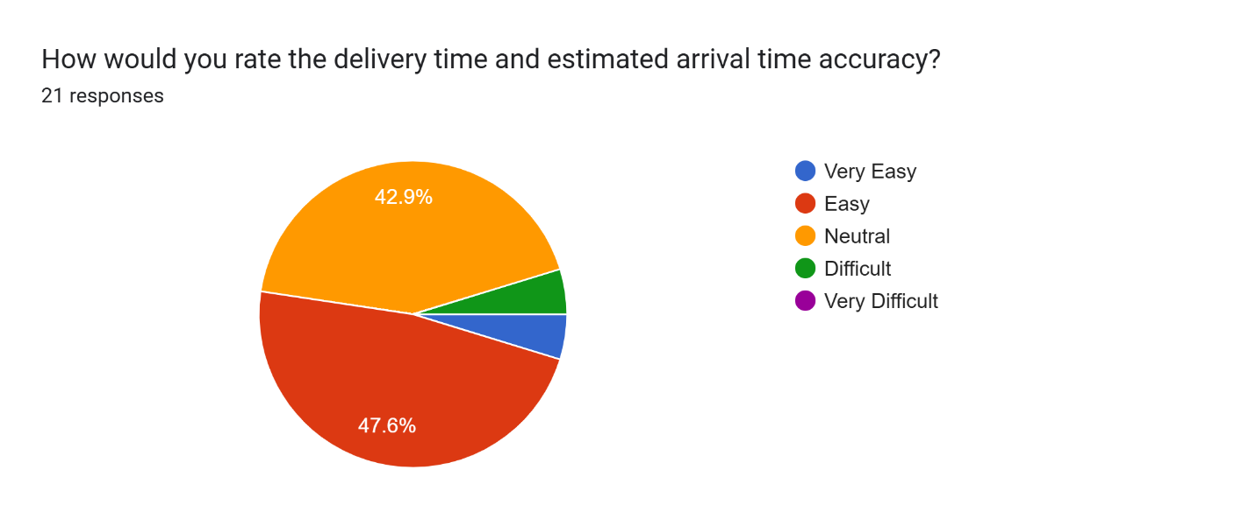
Figure 3.3 Overall estimated delivery time and arrival time accuracy
Figure 3.4 indicates that 61.9% show that, the food they received tasted good, and 38.1% also indicated that it was excellent.

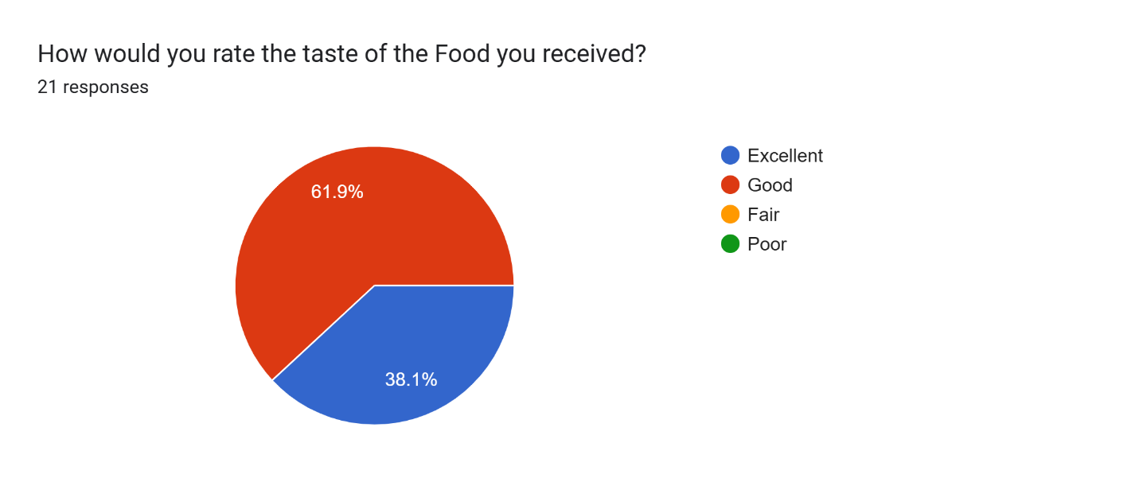
Figure 3.4 Overall experience with the food taste
In Figure 3.5, 76.2% of pupils indicated that they were happy with the food menu, 14.3% also said they weren’t happy with the food menu while 9.5% indicated that they were neutral.
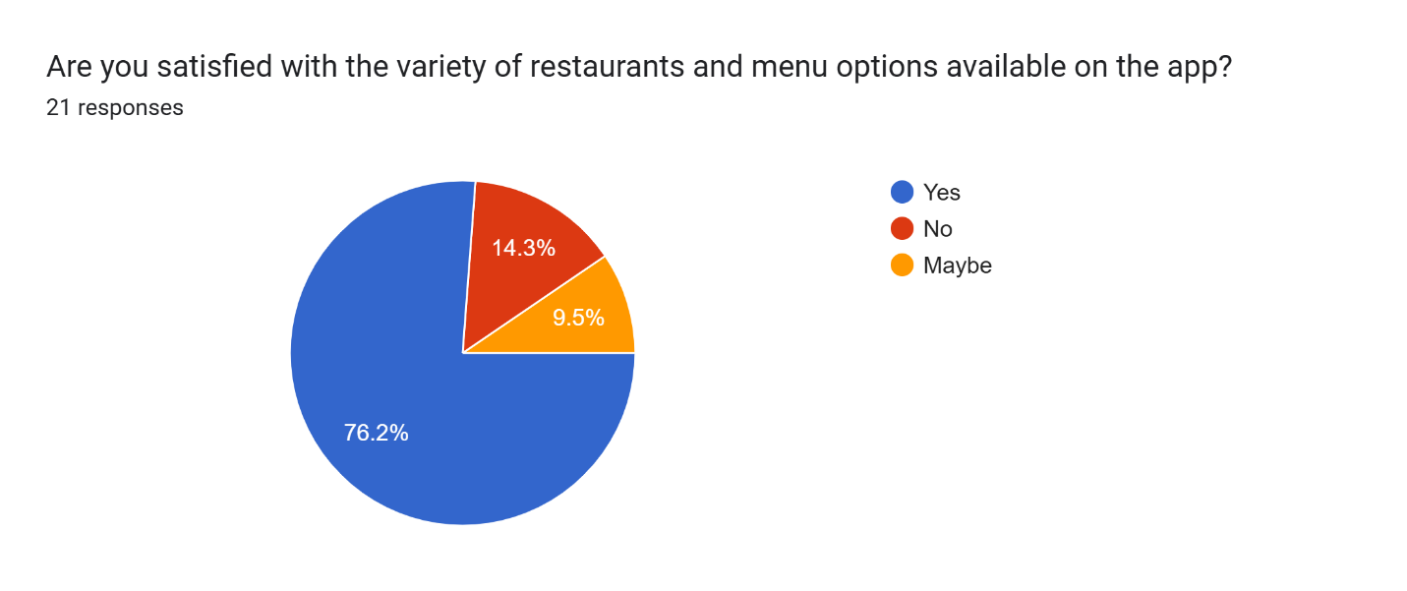
Figure 3.5 Overall satisfaction with the food menu
In Figure 3.6, 52.4% of the people indicated that it was easy when navigating through the app,23.8% of the people indicated that it was very easy which is the blue part of the pie chart while 23.8% also indicated they were ok when using the app.

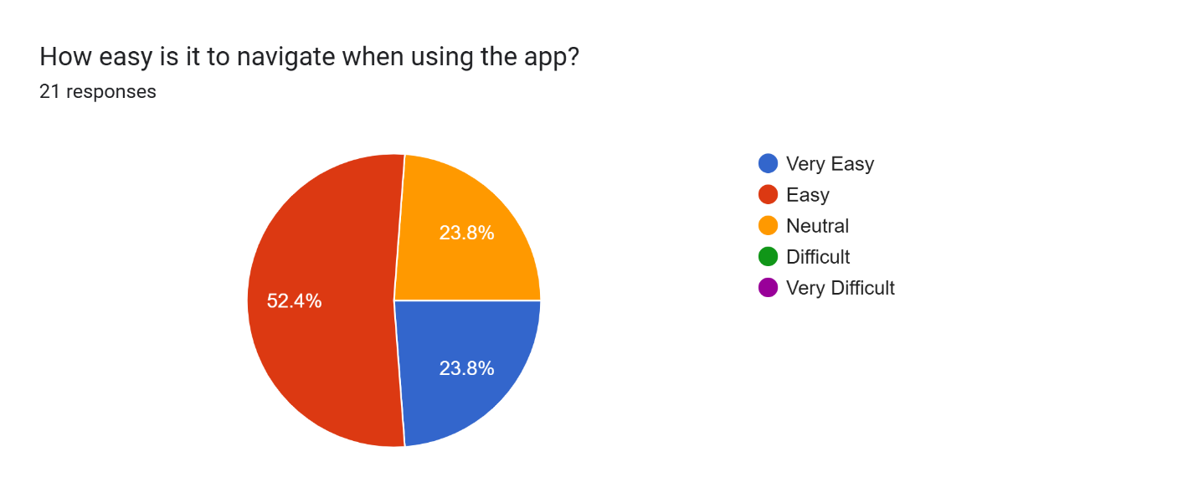
Figure 3.6 overall experience when navigating through the app

Figure 3.7 Indicated that 57.1% of the people indicated that they were experiencing issues while 42.9% showed that they were ok.

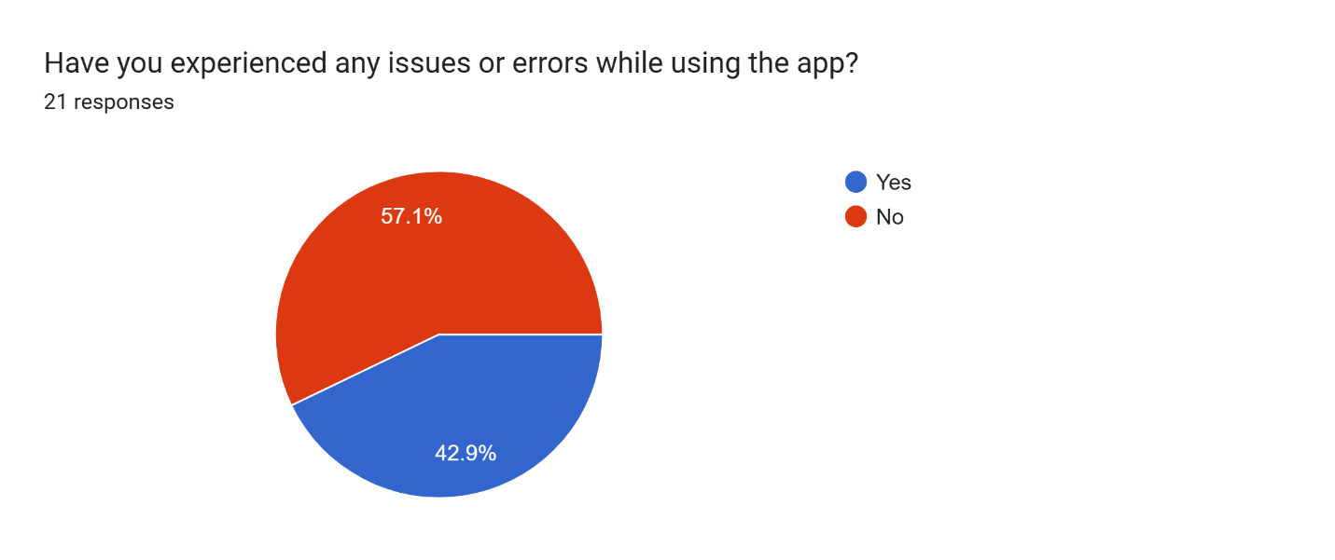
Figure 3.7 Experience with any issues
In figure 3.8 you will see that 5 which has the highest percentage indicated that the customer support team where helpful, 3 and 6 had the same percentage followed by 7,8,9 which has the same percentage and1,4 and 10 had the lowest percentage.
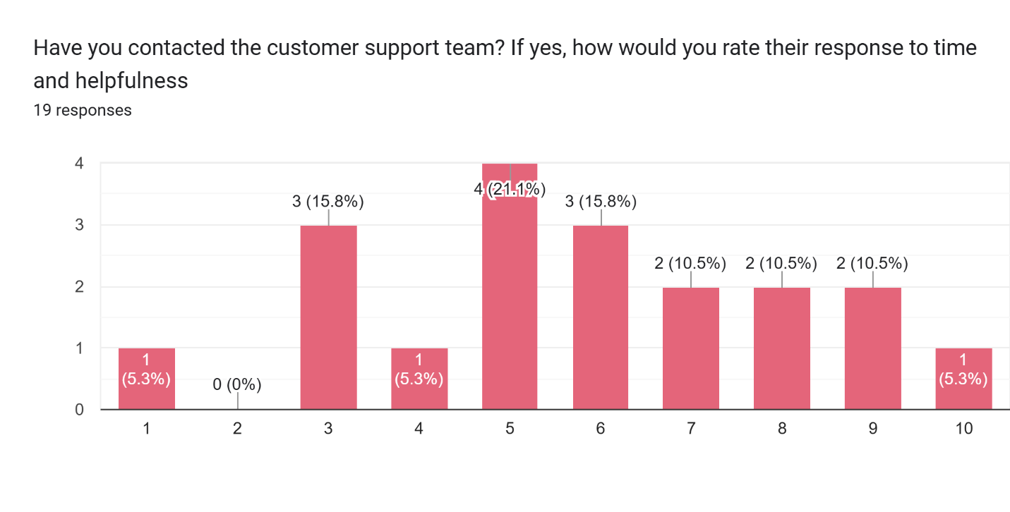
Figure 3.8 Overall experience with the food delivery app
Figure 3.9 shows that 55% of the survey we conducted indicated that they would likely recommend the food delivery app to their loved ones,35% indicated that they are very likely to recommend the food delivery app to their loved ones 10% also they don’t know whether they would recommend the food delivery apps or not.
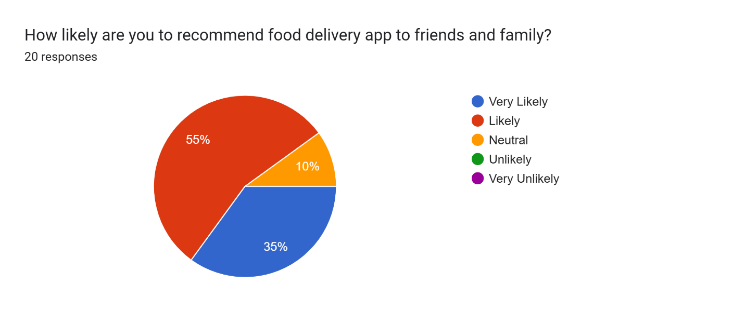
Figure 3.9 recommendation of the app
In Figure 3.10 47.6% pupils indicated they were clear with the payment option while 52.4% also indicated that they don’t know whether the payment option was clear or not.

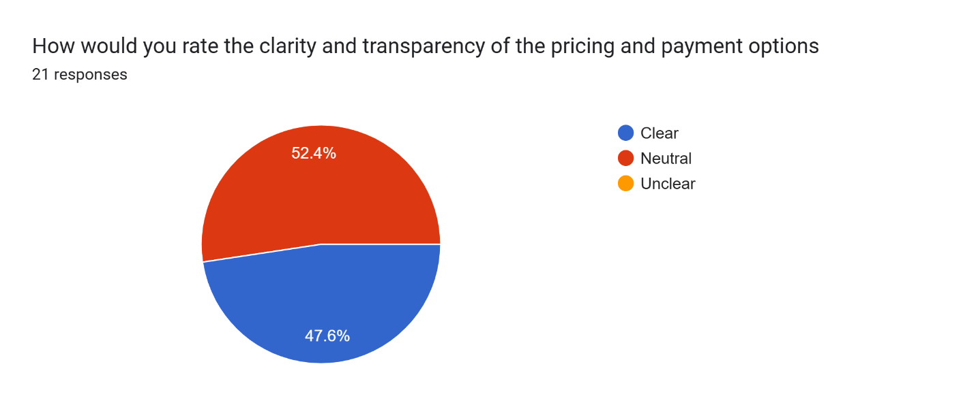
Figure 3.10 payments transparency options
Figure 3.11 indicated that 52.4% of the people are likely to continue to use the food delivery app,28.6% also indicated that they are very likely to use the food delivery app,14.3% also indicated that they are neutral while 4.7% also indicated that they are very unlikely.

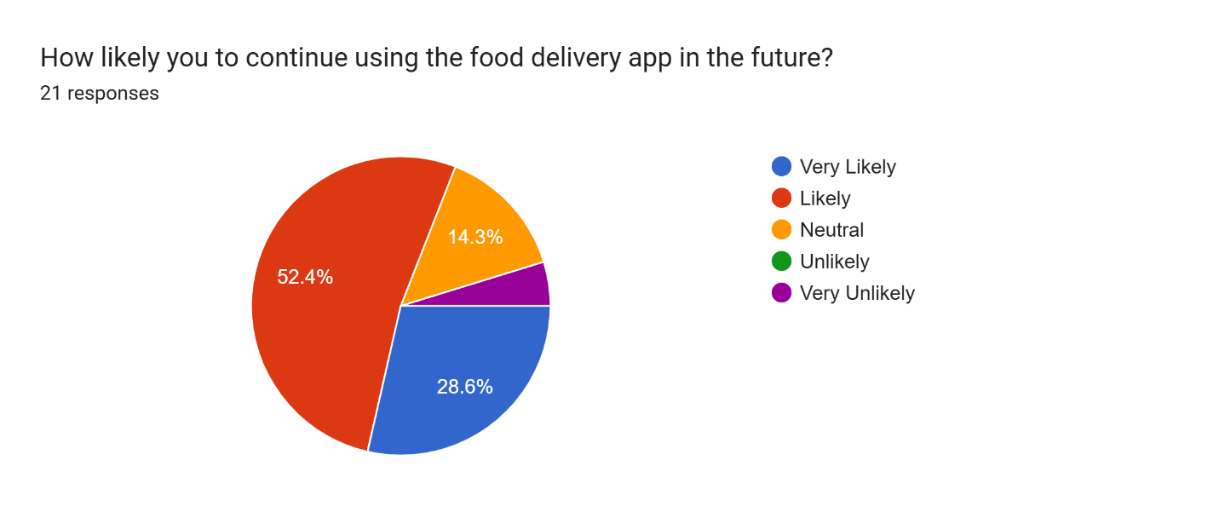
Figure 3.11 how likely would they continue to use the food delivery app

3.4 SAMPLING TECHNIQUE
In the current study, a sampling technique was used to get information and ideas from customers and users who have been paying for food from the internet, and also restaurants. It made it possible to find participants who have used the existing food delivery applications and could offer insights into each of the required features and interface. Hence, we used the UENR cafeteria as our study area.
- Planning
According to (Chotigo 2021) the first phase in the throwaway prototype model in which we set the project boundaries. This part is the value proposition and refinement of why to proceed with the construction of the food delivery app minus what approach the project team is going to take while constructing it. In this section, members ranked them based on priority, summarized what is relevant in terms of requirements of the tasks to be undertaken and then developed requirements table. This analysis was crucial because it made the concept less opaque and provided an understanding of whether it was workable in its prior form. This stage was very helpful in answering questions like why do we need the construction of this system and how should the team that is to construct the system conduct itself. The work plan ‘developed’ for this project is comprised of four main stages namely; research, design, development and testing stages. Agile model made it possible for the team to integrate and deploy continuously, which helped us fix some problems as we noticed them and build better features based on the interactions we had with the other teammates.
- Software Development
As at the development stage, it was noted that the team got a document, which contained the overall project description. The development phase determines how the system is going to be run. As for the computer software, hardware and network facilities that will be required. This was well done in the frontend development using Flutter alongside Dart for the backend development, and Firebase for database development. At the end of each phase, we expect to have accomplished part of the functionality of the application.
- Testing
During the development stage continuous evaluations were made to confirm that resolved errors and bugs were managed appropriately and multiple trial runs were executed. Deployment
Users can access the application during the deployment phase. After careful testing of the system, we then deploy it. At this stage, the system is installed for a wide range of users to access. This is where we make it public for all to access.
- Operations and Maintenance
The team is especially focused on maintenance at this stage and the development life cycle is nearly complete. The Program has been developed and is currently in use at the field. The concept is that when users engage and interact with the web application, they may be conducted to contribute feedback that can enable changes to be made and released in later versions. These errors must be corrected, and this will likely lead to even more steep spirals of the development cycle (Jevtic,2019). Users will be taught, and assistance will be provided to ensure that the system remains effective. The group focuses on the performance evaluation of the system with emphasis on the aspect of Hardware, Software and Database.

3.5 SYSTEM DESIGN
From software engineering perspective, according to GeeksforGeeks software development process is a process of breaking down the software development work into simpler more manageable, parallel or subsequent stages or sub-processes for better design and product.It may contain a list of deliverables defined in advance and implemented by a project team to build an application.
The product outcomes are meant to meet many different quantities. Some of these product important requirements include; Scalability, Reliability, Maintainability, and Usability was used. In this work, Agile System Development life cycle and quantitative method of research will be employed. Agile Software Development is a concept of software development cycle in which project is developed through iterative and incremental strategy that provides the capability of delivering a working software in short span of time. The Manual system was studied as part of the design strategy for the proposed system and then introduced to digital form as Food Delivery App.
As to the particulars of the implementation of the proposed system, it is suggested that during the first run the new system be introduced and the existing system be executed concurrently. This will help determine how efficient the system will be and it will also afford users ample time to familiarize themselves with the system before total implementation is made. First of all, we had to define tasks and consider its executions and the possibility of the project. The strategy of constructing the first prototype of the given interface for two assessment types and testing it was determined.

3.5.1 TECHNOLOGY STACK
The platform was developed using a combination of web technologies that support scalability, security, and responsiveness.
Frontend: A dynamic and responsive user interface was built using Dart and Flutter technology.
Backend: With Node.js as the engine the application sorted requests and controlled user sessions.
Database: To handle information on user food selections and payments data was stored in Firebase.3.5.2 Tools and Technologies
Version Control: Git and GitHub for collaborative development and version control.

3.5.2 Description of The Proposed System
The Food Delivery System serves as a mobile application accessible over the internet. To enhance safety in the Food Delivery System users, have to ensure their presence even after the system becomes idle.

A Brief Description of How the System Will Operate:

New users are expected to register and undertake a number of steps that may involve entering their first name, last name, email address, a password among other insertion. To existent users, they must log in or sign in, with a username and password they created the account with. When registering with the company, the clients are supposed to sign in by inputting their email address and password they used in creating the account. During the signup-process the users are expected to enter their email address and the password. This is an absolute must.
This is because users can view the total number of products that are available, or select food products, checkout the products, clear the products or proceed with payments for the product.

3.5.3 Feasibility Analysis
After that we undertook a feasibility analysis to determine the technical, operational and economic feasibility of the app. For the results, the study showed that the project was possible with the current technology stack, for example, we used Flutter and Dart on the project that is used in the development of Android and iOS as well as web-based apps. As quick food delivery services where growing in demand, we had a good chance of operational successes.

3.6 REQUIREMENT ELICITATION

3.6.1 Requirement Analysis
Through interviews and surveys online as well as competitor reviews key requirements emerged. This includes mandatory characteristics like user registration and restaurant viewing as well as payment integration. We assigned a priority level to the requirements as essential and desirable to guide our development.

3.6.2 Functional Requirements
- User Authentication and Registration
- Restaurant food list
- Order placement
- Payment Gateway integration
- Receipt from your order

3.6.3 Non-Functional Requirements
- Performance
- Usability

3.6.4 User Performance/Usability
The app was designed based on the importance of usability and user efficiency. Feedback from participants was essential for improving the interface ease. To enhance the app later on feedback was built into the process.

3.7 THROW AWAY PROTOTYPE MODEL
Figure 3.12 shows the throwaway prototype model. The developer will define the codification requirements that is the tools needed to develop the app, the developer will outline the model and build the real app from it, before the developer will evaluate the prototype and specify it to determine what additions he needs to make to the system. Newly it will be developed and next tested the system will then be developed and when the development is complete, the system will 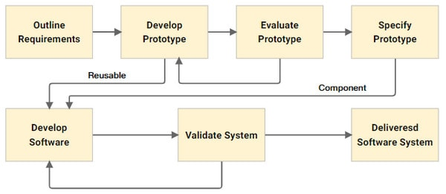
Figure 3.12 The Throwaway prototype model

3.8 FLOWCHARTS OF THE PROPOSED SYSTEM
Figure 3.13 represent the journey of users from signing in to order completion. This graphic makes it possible for all parts of the system to link up correctly and for data to flow effortlessly between them for a pleasant user experience.
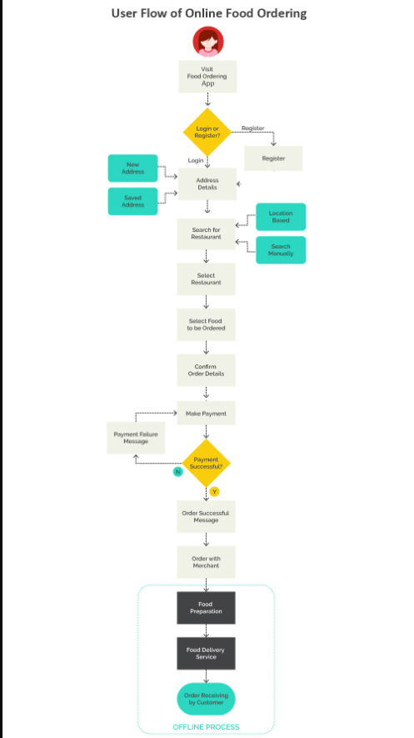
Figure 3.13 Flowchart of the proposed system (Adopted from Demo 2022)

3.9 ARCHITECTURAL DESIGN
The modular structure of the architectural design of the app is also for user authentication, menu browsing, order management and payment processing. This makes it possible for each component to be built, tested and upgraded separately as this makes the app more maintainable.
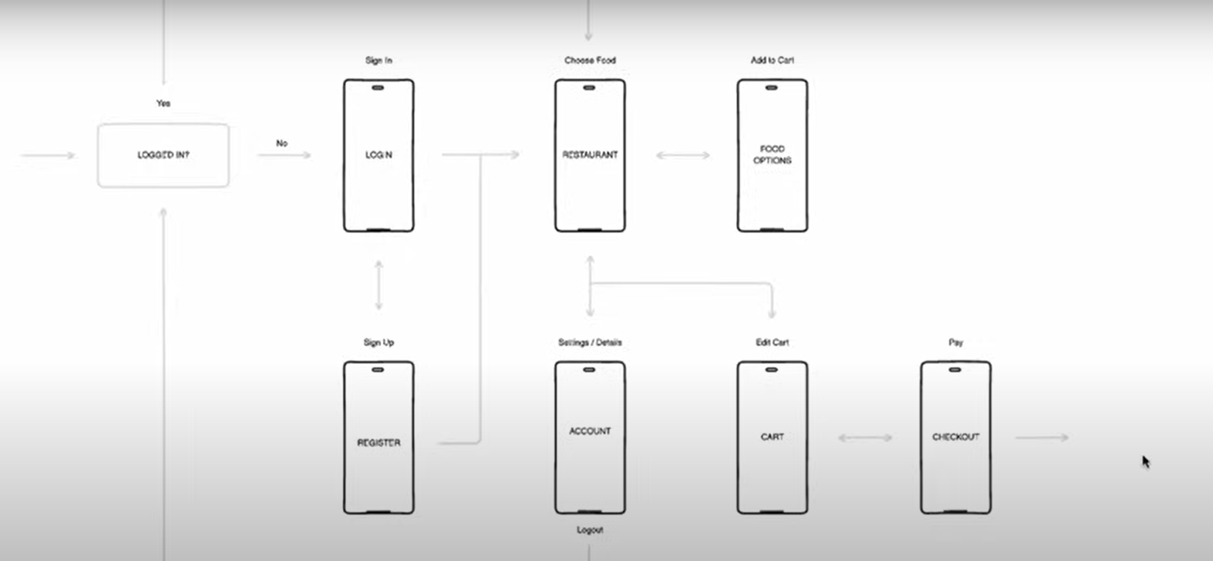
Figure 3.15 Architectural Design

3.9.1 Physical Requirement
The implementation of the application and the interface requires a development environment which includes Integrated Development Environments (IDEs) including the Android Studio as well as testing devices being the Android emulator the hosting of the back-end services include server infrastructure such as Firebase.

3.10 Use Case Diagram
Figure 3.16 shows how users (customers and delivery staff) connect with the system. It describes each user activity including the act of placing an order and administering restaurant listings.
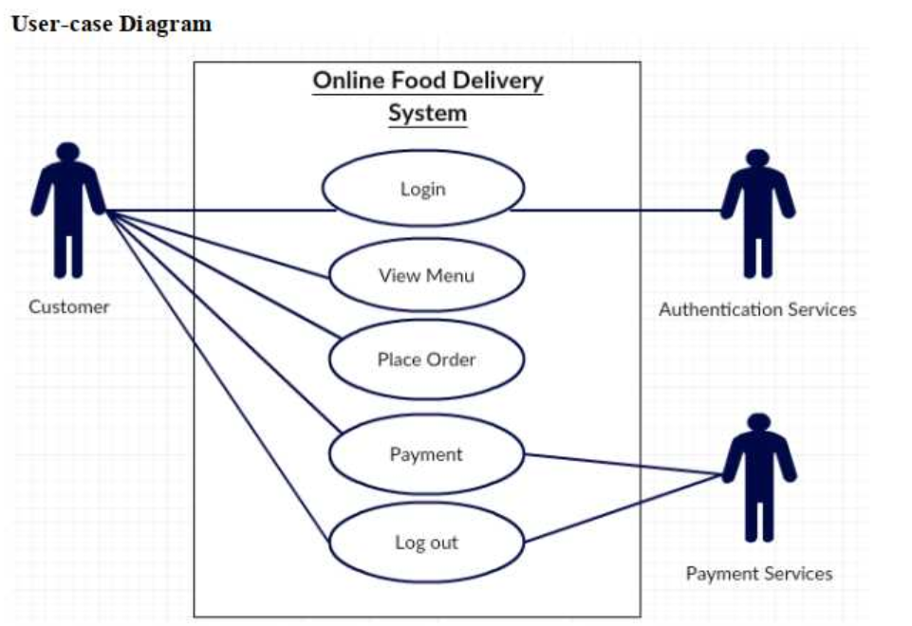
Figure 3.16 Use case diagram of the system

3.11 DATABASE DIAGRAM OF THE SYSTEM

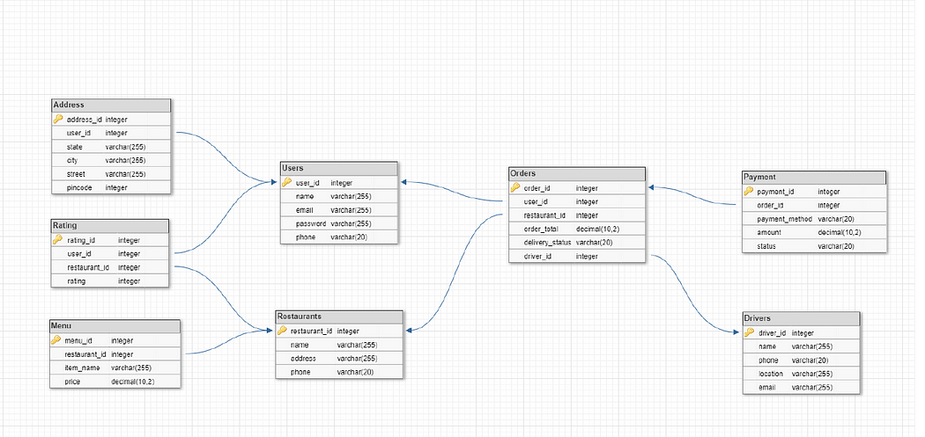
Figure 3.17 Database diagram

CHAPTER FOUR

RESULT AND DISCUSSION

4.1 INTRODUCTION
This chapter focuses on the application and development of the methodology proposed in Chapter 3. This approach acted as a guide to ensure that the project’s objectives were effectively completed, and it did so by providing a map to do so. The execution of the project was compartmentalized into three discrete stages, which were as follows:
- Development of the interface
- Development of the backend
- Integration of the project

4.2 SYSTEM DESIGN AND IMPLEMENTATION
The manual system in use was analyzed and this led to the conversion of the analyzed manual system into an Automated food delivery system design. To formally recommend the current system for use and the new one be implemented only during the first phase of the new system deployment. This will enable an evaluation of the extent to which the system will be effective and at the same time enable users to acquaint themselves with the system by the time the new system is fully put in place. The first thing that we did was evaluating what needed to be done or undertake also, the feasibility of the project. Based upon this, the decision of the study was made to proceed with the construction of a preliminary prototype that should then be tested.

4.3 USER INTERFACES
A user-friendly and concise interface was what the design pursued for the app. The UI design adheres to current UX guidelines to allow users effortless navigation.

4.3.1 Sign In page
- Email field: In this field users type their email addresses.
- Password field: Users enter their password in this other input field where it will probably be hidden for privacy.
- Sign-in button: To log into the app after filling out the email and password fields users press this button.
- Register now link: If users aren’t registered yet they may be taken to a page where they can create an account by clicking this link.

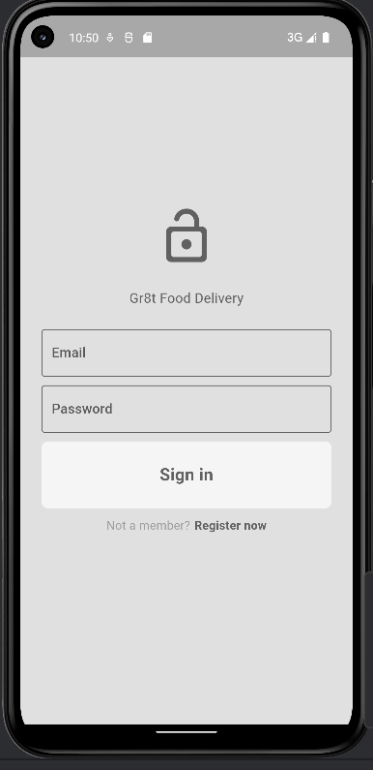
Figure 4.1 Sign In page

4.3.2 Sing Up page
- Email field: An account is set up after users enter their email addresses.
- Password field: Users provide the password they want for the account.
- Confirm Password field: To confirm their password is correct users are required to re-input it without errors.
- Sign Up button: By pressing this button a user sends the details (email and password) to establish the account.
- Login now link: People with existing accounts can use this. By selecting this option they revert to the login screen and are given the opportunity to sign in rather than set up a new account.

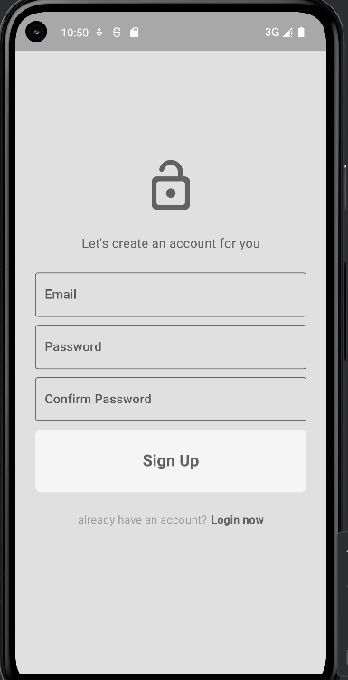
Figure 4.2 Sign Up page

4.3.3 App Menu Bar
On the menu bar in the application are available options labeled “HOME,” “SETTING,” and “LOGOUT”

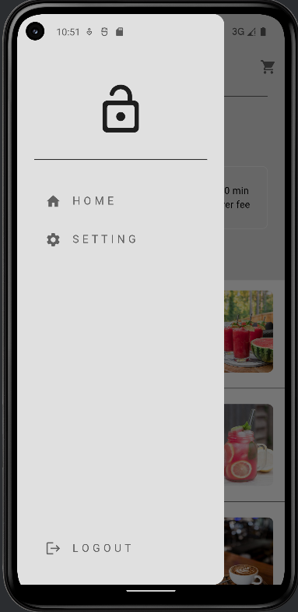
Figure 4.3 App Menu Bar

4.3.4 Food menu screen
- Delivery information: It displays delivery information along with a location. By clicking on the arrow next to the location users can edit the delivery spot. It reveals the delivery cost and the expected delivery time that indicates the delivery price and suggests a delivery time range.
- Restaurant items: Choices from the restaurant menu appear here along with their names and prices.
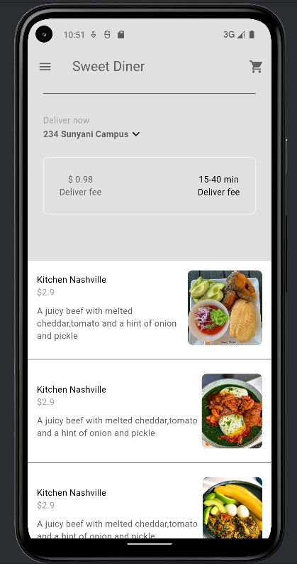
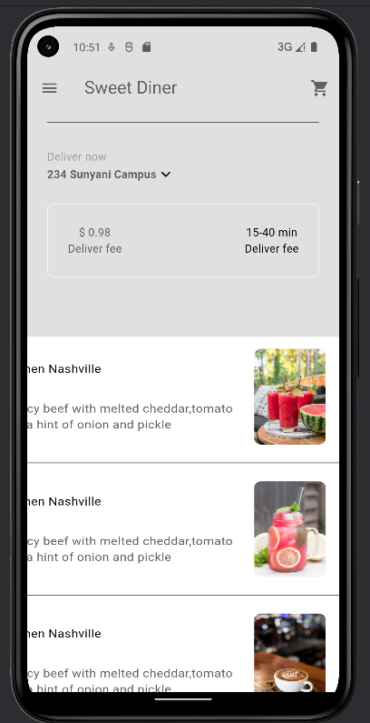
Figure 4.4 Food Menu Page

4.3.5 Location
People enter the desired location and keep it saved.
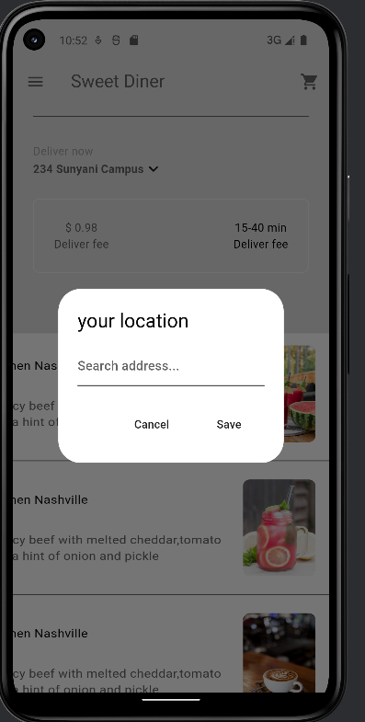
Figure 4.5 location page

4.3.6 Cart Page
In the cart of the app's design users have the ability to change the quantity and then go to checkout. All products provide alternatives for extras including fish and eggs at their individual prices. The platform caters to easy navigation so users can easily order with confidence. Now the item the user chose is shown; one can select the bin image in the top right corner to discard their item. In the cart section of the app a pop-up appears for the user to confirm or reject the emptying of the cart options.

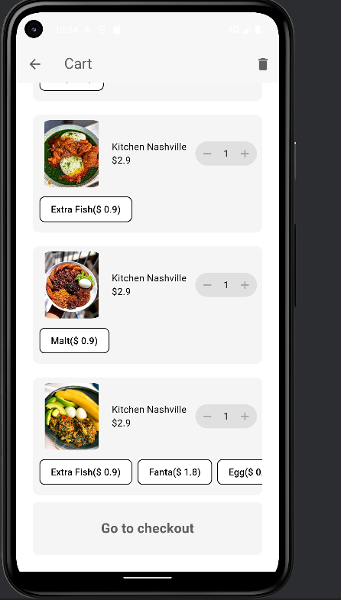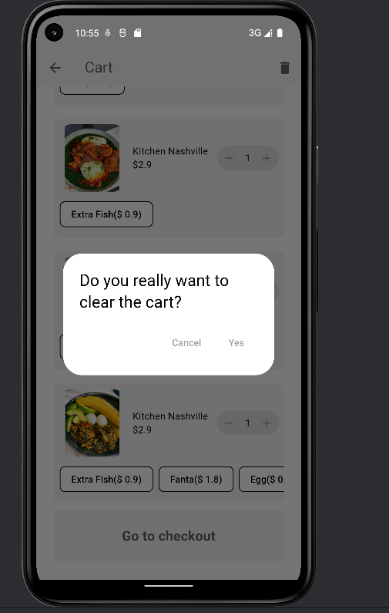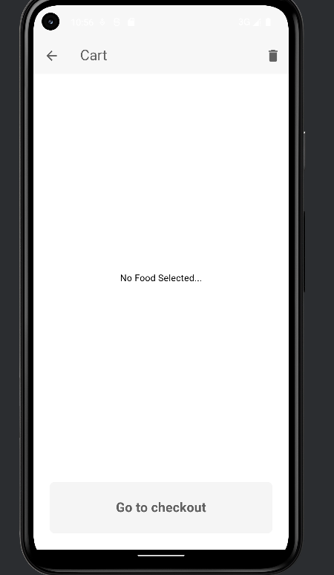
Figure 4.6 Cart page

4.3.7 Payment Page
On the checkout screen of the app users can input their payment card information like card number and expiry date before confirming the payment via "Pay Now”. On the payment confirmation screen users are able to assess their card information and approve the transaction by selecting "Yes" or cancel. To make payment click “Pay Now.”
On the payment confirmation screen of the app users may evaluate their card details and make transaction by choosing “Yes” or rejecting it.

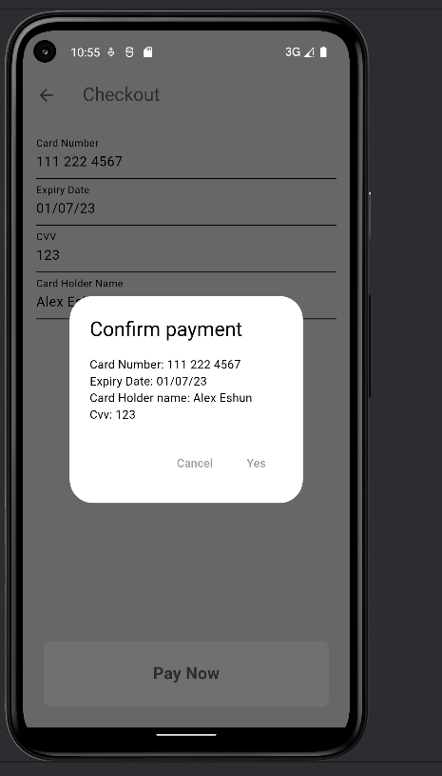
Figure 4.7 Payment page
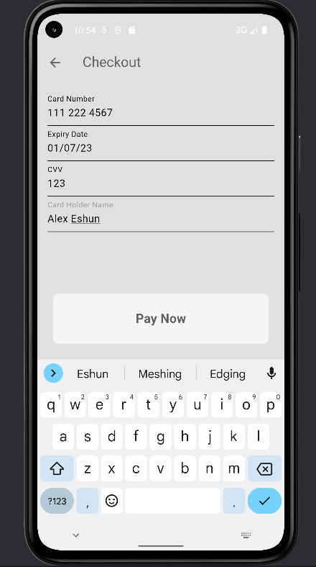

4.3.8 Display Receipt
An order receipt is presented by the app for a meal showing the items along with their amounts and individual prices. A date and time appear on the receipt.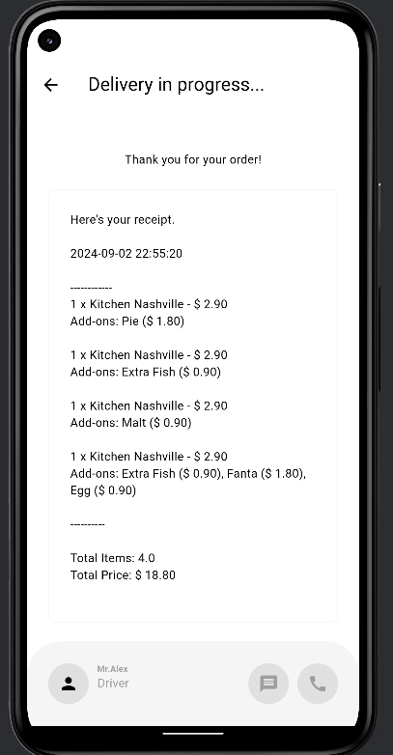
Figure 4.8 Receipt Page

CHAPTER FIVE

SUMMARY, RECOMMENDATION AND CONCLUSION

5.1 INTRODUCTION
The Food Delivery App is a kind of application that will enhance a way through which people order foods from the comfort of their homes. The improvement is going to occur right in this industry, and its occurrence can be attributed to the Food Delivery App. This application can be operated on a mobile phone and it is usable on internet.

5.2 RECOMMENDATION
Continuous Stakeholder Engagement: Continue weekly contact with bricks and mortar fast food joint, stakeholders. It is also advisable to set a date for feedback sessions in order to check how frequently users make changes and what they would like to change about the platform.
Regular System Updates: Set a pattern for frequent updates and control to preserve performance and protect safety during the transition to new food delivery and tech protocols.
Incorporate User Feedback Mechanism: Design means for users to present their issues or introduce fresh concepts. Users can either fill in forms or submit ideas in an allocated corner.

5.3 FUTURE WORKS
To accommodate more research efforts some capabilities have been removed from the analysis. Introducing additional modules and features that will serve everyone since it enables the person to view food in different sizes from pattern that will be introduced in future.

5.4 CONCLUSION
The field of computer technology is updated every day. Every minute brings new technologies which means that systems need to be built around updates to boost existing capabilities and add new ones. The objective behind the food delivery software is to fix the issues present in present day services by delivering a straightforward application and numerous restaurant options.
To achieve long-term success and sustainability for the system the recommendations must be put into practice. With restaurant partnerships and user-focused changes the platform will significantly improve food delivery services in Ghana. Reaching these targets will grant our users a straightforward and delightful food ordering experience and allow our app to dominate the food delivery industry.

REFERENCE

Collison, J. (2020). The impact of online food delivery services on restaurant sales. Stanford University. Retrieved from https://www.geeksforgeeks.org/software-engineering-agile-software-development/
Domo. (2022). Data never sleeps 10.0. Retrieved from Domo. https://www.domo.com/learn/infographic/data-never-sleeps-10
GeeksforGeeks. (n.d.). Agile software development. Retrieved from https://www.geeksforgeeks.org/software-engineering-agile-software-development
Greenwood, T. (2021). Sustainable web design. A Book Apart.
Guimaraes, M. N. (2017). Product development: Dealing with consumer demands during the development of sustainable textile products [Doctoral dissertation, University of Manchester]. Retrieved from https://ethos.bl.uk/OrderDetails.do?uin=uk.bl.ethos.822908
Isabella Sundquist & Zurawska, K. J. (2023). Low-impact user interfaces: How can we create a climate-smart approach toward front-end mobile application design.
Jevtic, G. (2019). What is SDLC? Phases of software development and models. Retrieved from https://phoenixnap.com/blog/software-development-life-cycle
Chotigo J. and Kadono Y. (2021).Comparative Analysis of Key Factors Encouraging Food Delivery App Adoption Before and During the Covid-19.Sustainability
National Geographic Society. (2024). Food. Retrieved from https://education.nationalgeographic.org/resource/food
Statista. (2022). Annual global mobile app downloads 2021-2026. Retrieved May 2023, from https://www.statista.com/statistics/1010716/apple-app-store-google-play-app-downloads-forecast/
Statista. (2023a, February 14). User-generated internet content per minute 2022. Retrieved May 2023, from https://www.statista.com/statistics/195140/new-user-generated-content-uploaded-by-users-per-minute/
Statista. (2023b, April 26). Internet usage worldwide. Retrieved May 2023, from https://www.statista.com/topics/1145/internet-usage-worldwide/#topicOverview
Statista. (2023c, April 27). Global mobile traffic share by region 2023. Retrieved May 2023, from https://www.statista.com/statistics/306528/share-of-mobile-internet-traffic-in-global-regions/
Tokareva, J. (2018, May 25). What is the difference between e-commerce and mobile commerce? Forbes. https://www.forbes.com/sites/quora/2018/05/25/what-is-the-difference-between-e-commerce-and-mobile-commerce/?sh=76d7c2784c6d
Throwaway prototype model: Throwaway-prototyping-system-model.
i

APPENDIX
import 'package: flutter/material.dart';
Class MyButton extends StatelessWidget {
final Function()? onTap;
final String text;
const MyButton({
super. key,
this.onTap,
required this. text});
@override
Widget build(BuildContext context) {
return GestureDetector(
onTap: onTap,
child: Container(
padding: const EdgeInsets.all(25),
margin: const EdgeInsets.symmetric(horizontal: 25),
Decoration:
BoxDecoration(
color: Theme.of(context).colorScheme.secondary,
borderRadius: BorderRadius.circular(8)
),
child: Center(
child: Text(
text,
style: TextStyle(
fontWeight: FontWeight.bold,
color: Theme.of(context).colorScheme.tertiary,
fontSize: 20
),
),),
),
);
}
}

import 'package:flutter/material.dart';
import 'package:greatfood/components/my_button.dart';
import 'package:greatfood/components/my_cart_tile.dart';
import 'package:greatfood/models/restaurant.dart';
import 'package:greatfood/page/payments_page.dart';
import 'package:provider/provider.dart';
class CartPage extends StatelessWidget {
const CartPage({super.key});
@override
Widget build(BuildContext context) {
return Consumer<Restaurant>(builder: (context,restaurant,child){
//cart
final userCart= restaurant.cart;
//scaffold UI
return Scaffold(
appBar: AppBar(
title: const Text("Cart"),
backgroundColor: Colors.transparent,
foregroundColor: Theme.of(context).colorScheme.tertiary,
actions: [
//clear cart button
IconButton(
onPressed: (){
showDialog(
context: context,
builder: (context)=>AlertDialog(
title: Text("Do you really want to clear the cart?"),
actions: [
//cancel button
TextButton(onPressed: ()=>Navigator.pop(context),
child:const Text("Cancel")
),
//yes
TextButton(onPressed: (){
Navigator.pop(context);
restaurant.clearCart();
},
child:const Text("Yes")
),
],
));
},
icon: const Icon(Icons.delete)
),
],
),
body: Column(
children: [
//list of cart
Expanded(
child: Column(
children: [
userCart.isEmpty?
const Expanded(
child: Center(
child: Text("No Food Selected..."),
),
)
:Expanded(
child: ListView.builder(
itemCount: userCart.length,
itemBuilder: (context,index){
//get individual cart item
final cartItem=userCart[index];
//return cart UI
return MyCartTile(cartItem: cartItem);
return ListTile(
title: Text(cartItem.food.name),
);
}
),
),
],
),
),
//button to pay
MyButton(
onTap:()=>Navigator.push(
context,
MaterialPageRoute(
builder:(context)=>const PaymentsPage() )
),
text:"Go to checkout"),
const SizedBox(height: 25,)
],
),
);
});
}
}

food_page.dart file
import 'package:flutter/material.dart';
import 'package:greatfood/components/my_button.dart';
import 'package:greatfood/models/restaurant.dart';
import 'package:provider/provider.dart';
import '../models/food.dart';
class FoodPage extends StatefulWidget {
final Food food;
final Map<Addon,bool>selectedAddons={};
FoodPage({
super.key,
required this.food,
}){
//initialize selected addons to be false
for (Addon addon in food.availableAddons){
selectedAddons[addon]=false;
}
}
@override
State<FoodPage> createState() => _FoodPageState();
}
class _FoodPageState extends State<FoodPage> {
//method to add to cart
void addToCart(Food food,Map<Addon,bool>selectedAddons){
//close the current food page to go back to menu
Navigator.pop(context);
//format the selected addons
List<Addon> currentlySelectedAddons=[];
for(Addon addon in widget.food.availableAddons){
if (widget.selectedAddons[addon]==true){
currentlySelectedAddons.add(addon);
}

